DAGMAR Approach: Definition, Advantages, Examples

DAGMAR is a marketing expression that stands for “**D**efining **A**dvertising **G**oals for **M**easured **A**dvertising **R**esults”. It is a marketing tool to compute the results of an advertising campaign. DAGMAR attempts to guide customers through ACCA model. According to this approach, every purchase encounters four steps; Awareness, Comprehension, Conviction, and Action. DAGMAR method is an established technique of creating effective advertising.

[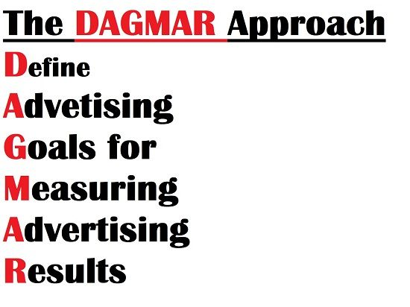](https://studiousguy.com/wp-content/uploads/2018/05/DAGMAR.jpg)

**HISTORY**

**DAGMAR** is an advertising model proposed by Russell Colley in 1961. Russell Colley advocated that effective advertising seeks to communicate rather than to sell. Advertisers discover whether their message conveyed enough information and understanding of a product to their consumers and also its respective benefits from clear objectives.

**The DAGMAR Model**

[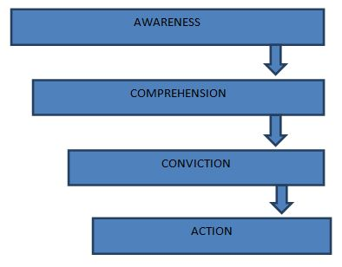](https://studiousguy.com/wp-content/uploads/2018/05/The-Dagmar-Model.jpg)

**1. AWARENESS**

* Awareness of the existence of a product or a service is needful before the purchase behaviour is expected. The fundamental task of advertising activity is to improve the consumer awareness of the product.
* Once the consumer awareness has been provided to the target audience, it should not be forsaken. The target audience tends to get distracted by other competing messages if they are ignored.
* Awareness has to be created, developed, refined and maintained according to the characteristics of the market and the scenario of the organization at any given point of time.
* The objective is to create awareness about the product amongst the target audience.

**2. COMPREHENSION**

* Awareness on its own is not sufficient to stimulate a purchase. Information and understanding about the product and the organisation are essential. This can be achieved by providing information about the brand features.
* Example: In an attempt to persuade people to budge for a new toothpaste brand, it may be necessary to compare the product with other toothpaste brands, and provide an additional usage benefit, such as more effective than other toothpaste because it contains salt or that this particular toothpaste is a vegetarian toothpaste, which will, in turn, attract more customers.
* The objective is to provide all the information about the product.

**3. CONVICTION**

* Conviction is the next step where the customer evaluates different products and plans to buy the product. At this stage, a sense of conviction is established, and by creating interests and preferences, customers are convinced that a certain product should be tried at the next purchase.
* At this step, the job of the advertising activity is to mould the audience’s beliefs and persuade them to buy it. This is often achieved through messages that convey the superiority of the products over the others by flaunting the rewards or incentives for using the product.
* Example: Thumbs up featured the incentive of social acceptance as “grown up”. It implied that those who preferred other soft drinks were kids.
* The objective is to create a positive mental disposition to buy a product.

**4. ACTION**

* This is the final step which involves the final purchase of the product. The objective is to motivate the customer to buy the product.

**Advantages of DAGMAR Approach**

A major contribution of Colley’s DAGMAR approach was a specification of what constitutes a good objective.

[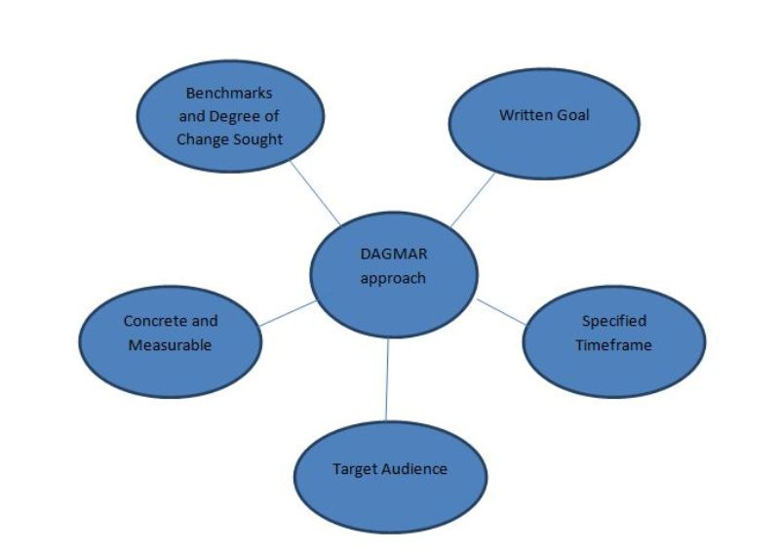](https://studiousguy.com/wp-content/uploads/2018/05/Advantages-Of-Dagmar-Approach.jpg)

Sponsored

According to Russell Colley, there are various advantages of well-founded objectives. These are:

* Be concrete and measurable
* Have a well-defined target audience or market
* Identify the benchmark and the degree of change
* Specify a timeframe to accomplish the objective

**TARGET AUDIENCE**

* DAGMAR claims the target audience is well defined. A group of potential customers, who have the highest likelihood of purchasing the product, is the target market. Identifying the target market includes the process of demographic, geographic, and psychological segmentation. Target markets can be segmented into **Primary** and **secondary groups**.
* **Primary markets** are the main target audience, on whom the marketing efforts are mainly focused.
* **Secondary markets**are the target audience on whom the marketing efforts will focus after the primary market goals are achieved. After identifying the target audience, the organization devises objectives for advertising and later the objectives for communication.

**CONCRETE AND MEASURABLE**

* The objective of communication should be a precise and clear statement of whatever message the advertiser wants to communicate to the target audience.
* The specification must include all the details and descriptions of the measurement procedure.

**SPECIFIED TIMEFRAME AND BENCHMARKS**

* A good objective has a specified time frame, during which the objective is to be achieved. Understanding the specifications enables advertisers to define goals that will yield the best result.
* Setting a specific timeframe assures effective evaluation of results. The timeframe should be realistic to prohibit skewed results from static marketing.
* Creating the benchmark is essential for an appropriate measurement of the effectiveness of the advertisement.

**WRITTEN GOAL**

* The goal should be committed on a paper. When the goals are clearly written, basic shortfalls and flaws are exposed, it becomes eventually easy to determine whether the goal contains the crucial aspects of the DAGMAR approach.

**OBJECTIVES OF DAGMAR APPROACH**

* Persuade a prospect to visit the showroom.
* Growth in market share.
* Improve sales turnover.
* Perform complete selling function.
* Advertise a special reason to buy.
* Stimulate impulse sales.
* Remind people to buy.
* Create awareness about the product and brand existence.
* Create favourable emotional disposition towards the product.
* Impart information regarding benefits and distinctive features of the product.
* Combat and offset competitive claims.
* Correct false impressions, wrong information and other hindrances to sales.
* Aid sales force with sales promotion and selling activities and boost their morale.
* Establish brand recognition and acceptance.

**EXAMPLE OF DAGMAR APPROACH**

Let’s suppose that an ABC company wants to evaluate the effectiveness of marketing campaign for its latest product launched. The company starts evaluating the commercial that is designed to persuade potential consumers through the four stages of the buying process:

1. In the **AWARENESS** stage, company ABC spreads awareness among the consumers about its new product launched in the market.
2. In the **COMPREHENSION**stage, company ABC portrays to its consumers the features and distinctiveness of the new product and reminds the consumers of the company ABC’s logo and brand name.
3. In the **CONVICTION**stage, company ABC attaches the consumer emotionally to the new product so that the consumer establishes an emotional preference for the company ABC’s brand.
4. In the **ACTION**stage, company ABC makes sales.

Company ABC then evaluates the success of the marketing effort using DAGMAR. The company measures that how fast the customer processed through the four stages of the purchase and how many sales were generated. In cases where the customer is distracted and deviated from buying the product, and the company doesn’t meet sales goals, the company needs to change its ad campaign.

Advertising is strongly associated with economic cycles across major world economies. The DAGMAR method is a long-established method of creating effective advertising. The idea behind the method is to**“communicate rather than sell”.**